# Connecting a battery pack through a voltage regulator

As a first circuit, you might connect a 330Ω resistor to the top power rail and then a 5-hole group, then connect an LED's positive leg to another hole in that same group and the other leg back to the negative rail, as shown (use the specific columns shown).

**Note:** You may use a [graphical resistor calculator](http://www.sorion-group.com/Resistor/resistor.htm) or reference a [chart](http://www.bpesolutions.com/bpemanuals/Resistor.Chart.1.gif) if you are unfamiliar with resistors. Resistors are always measured in Ohms (Ω).

|  |  |
| --- | --- |
|  | Make sure LED's longer leg is at bottom. |

**Note**: When connecting a battery always connect the positive (red) terminal first and then the negative (black). This is because electrons flow from negative to positive and you reduce the risk of creating a short.

Upon connecting a battery as shown, the LED should light. Now remove the battery wires.

The schematic for that first circuit is shown below, along with an illustration of how current flows from the battery, through the resistor, through the LED, and back to the battery.

|  |  |
| --- | --- |
|  |  |

The resistor is needed to limit current flow through the LED; the LED datasheet indicates the maximum current that should flow through, typically around 10 mA - 20 mA. It also indicates the typical voltage drop that will occur across the LED; the remaining voltage drop V will occur across the resistor, so the current that will flow can be computed using V = IR (e.g., if the battery outputs 6V and the LED voltage drop is 4V, the remaining 2V will occur across the resistor. If R is 200Ω, then current will be 2V / 200Ω = 10 mA).

Example: (resistance calculation for the diagram above)

VS: direct current voltage source

VD: voltage required to turn on LED

VR: voltage across the resistor in series with LED

I : maximum current flowing through LED for correct operation

VS = 6 volts (V), VD = 4 volts (V), I = 10 milliamps (mA)

VR = VS - VD

R = VR/I

R = (6V - 2V) / 10mA

R = 200Ω

Let's keep the LED and resistor there as an indicator of when the board is powered.

### **Basic board wiring for power**

We'll run power through a voltage regulator that reduces a higher voltage down to 5V, to protect the chips and other devices we'll put on the board. This way, if we accidentally apply too high of input voltage, the regulator will reduce it, or will burn out trying (It is far cheaper to replace a voltage regulator than a microcontroller). The voltage regulator's left pin is power-in, middle is ground, and right pin is power-out (5V, which we'll also call VCC).

Make sure the board is NOT powered (always disconnect power when adding/removing board components). Add the voltage regulator and add connectors from the right pin to the top power rail and from the middle pin to the top ground rail, as shown below on the left.

|  |  |
| --- | --- |
|  |  |

To make clear where the battery pack's black and red wires should connect, add short black and red wires as shown above on the right. With the available wires in our kit, we had to color a wire black (it was previously orange).

Now connect the battery to the holes next to the short red/black wires, and again the LED should light, as shown below. You might check voltages using a multimeter. Remove the battery wires.

**Note**: The voltage regulator may get hot during operation, so avoid touching it during operation.

**Note**: How to Insert/Remove Batteries:

Inserting a battery: connect positive (red), then connect negative (black).

Removing a battery: remove negative (black), then remove positive (red).

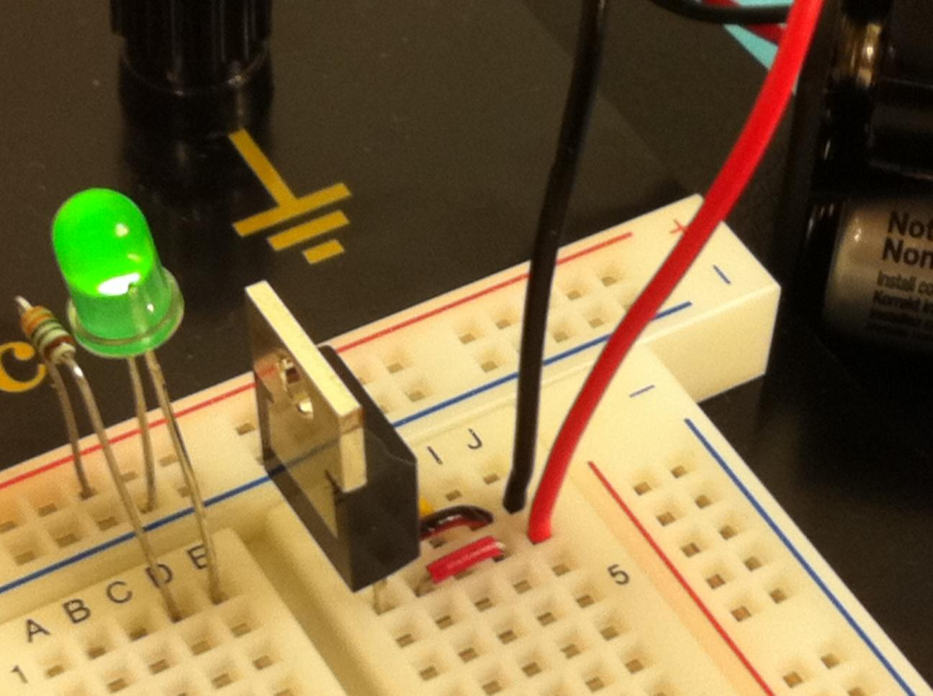

Connect the horizontal power/ground rails to all vertical power/ground rails as shown below.

|  |  |
| --- | --- |
|  |  |

On the top rail's right, we've added tape with an "X" to remind ourselves not to plug the battery into the top rail, but rather to plug in next to the voltage regulator.

Check that all power/ground rails have power by connecting the battery as earlier and using LEDs or a multimeter on each vertical power/ground pair to ensure they have power. Remove the battery wires.

***Important Note*:** If at any time while the power supply is connected you smell burning, or feel excessive heat coming from a component *disconnect your power source immediately and check your wiring!* *Do not touch any components, until they cool down.* If this happens you possibly have miswired the board and are burning components. They may still work afterwards but they also may be toast! Be sure to consider this when debugging.